Title of the paper: Can Deep Trade Agreements Absorb Geopolitical Shocks? Global Evidence from Intermediate-Goods Supply Chains
Author: Vu Ha Vy, Pham Quang Truc
Affiliation: Faculty of International Economics, Foreign Trade University, Hanoi, Vietnam
Position: Undergraduate Student
Email: k62.2312450141@ftu.edu.vn
Telephone: +84 934 441 231
Proposed track: Global Supply Chain Management under Geopolitical Risks and Policy Uncertainties
Submission category: Full paper
Word count:

ABSTRACT
Does institutional depth in preferential trade agreements condition the resilience of cross-border production networks to geopolitical risk? Using a global panel of intermediate-goods trade covering 160 economies from 2007 to 2023, this study estimates high-dimensional fixed-effects PPML models of trade values and linear probability models of annual link survival and post-exit recovery. A one-standard-deviation rise in global geopolitical risk is associated with an additional 2.38 percent decline in trade between preferential-agreement partners relative to non-partners, concentrated in differentiated manufacturing, while agreement depth does not significantly moderate this response. At the extensive margin, ten additional enforceable provisions are associated with a 0.52-percentage-point fall in annual link survival per standard deviation of risk, concentrated among smaller links: a pattern consistent with, but not direct evidence of, a fixed-cost mechanism. With country-specific risk measures, depth is associated with higher continuing trade values but lower link survival. Provision-level estimates do not survive correction for multiple testing, and no robust effect on post-exit re-entry is found. Agreement depth therefore does not provide uniform resilience across margins, and evaluations based only on aggregate trade values may overlook the thinning of the network of active links.
Keywords: Deep trade agreements; Geopolitical risk; Intermediate goods; Global value chains; Trade-link survival; Gravity model

1. Introduction
Geopolitical risk has become a persistent source of instability for international production networks. Successive episodes since 2014, from the sanctions on Russia to the war in Ukraine, have made inter-state tension a recurrent feature of the trading environment (Caldara & Iacoviello, 2022), and trade is reorganising along bloc lines (Campos et al., 2023; Gopinath et al., 2025). In the 2014 sanctions episode the sanctioning countries lost about US$42 billion in exports, mostly in products no measure had targeted (Crozet & Hinz, 2020). For firms embedded in cross-border production, such shocks mean cancelled orders and, at the limit, the end of supplier relationships (Boehm et al., 2019; Novy & Taylor, 2020).
Trading relationships do not respond uniformly. Transmission is state-dependent, shaped by the relationship-specificity of the inputs exchanged (Nunn, 2007; Rauch, 1999), the short-run substitutability of suppliers (Barrot & Sauvagnat, 2016) and the concentration of the trade network (Kramarz et al., 2020). The institutional depth of the preferential agreement governing a relationship is an important but unexamined condition: agreements have grown steadily in legally enforceable content (Hofmann et al., 2019), and the case for “friend-shoring” rests on the premise that institutional commitment makes partner supply chains more resilient (Javorcik et al., 2024).
Depth may work in either direction. Viewed as endogenously incomplete contracts (Horn et al., 2010), deeper agreements close gaps in commitment and remove uncertainty about future policy (Handley & Limão, 2017), and so should dampen the response to a shock. Viewed through the global-sourcing model (Antràs & Helpman, 2004), the same provisions induce the relationship-specific investment that constitutes exposure, and the fixed cost of maintaining preferential status (Anson et al., 2005) falls hardest on the smallest relationships. Depth is therefore a structural condition whose sign cannot be assumed in advance (Grossman et al., 2023).
Three gaps remain. First, estimates of the trade effects of geopolitical risk are obtained for countries or broad sectors (Bloom, 2009; Caldara & Iacoviello, 2022), whereas the mechanisms they invoke operate between a particular pair trading a particular product. Second, the deep-agreement literature estimates level effects in ordinary times (Laget et al., 2020; Mattoo et al., 2022; Osnago et al., 2019) and has not asked whether depth conditions the response to a shock. Third, most evidence concerns trade values, although the survival of relationships is where fixed costs bite (Besedeš & Prusa, 2006a; Melitz, 2003), and the two margins may respond with opposite signs. This study addresses them on a panel of bilateral intermediate-goods trade covering 160 economies, 88 HS two-digit chapters and 2007–2023 (16.75 million observations), combined with the World Bank Deep Trade Agreements database and the Caldara and Iacoviello (2022) index. Because global risk is absorbed by time-varying fixed effects, identification exploits cross-sectional variation in agreement membership and depth.
Global geopolitical risk is therefore a contextual variable rather than an independently identified treatment: the question is not whether it reduces intermediate-goods trade, but why some relationships contract, or disappear, more than others under the same shock. The study addresses four questions:
1. Does intermediate-goods trade between preferential-agreement partners contract by more than trade between comparable non-partner pairs when global geopolitical risk rises, and does the differential follow the sectoral ordering that relationship-specificity predicts?
2. Does agreement depth dampen or amplify the response of trade values to geopolitical risk?
3. Does the conditioning effect of depth differ between trade values and the extensive margin of trade-link survival?
4. Is any adverse effect of depth on post-exit re-entry transitory or permanent?
The paper contributes in three ways. First, it provides global pair–product evidence on the interaction between geopolitical risk and agreement depth on both margins: trade between preferential partners falls by a further 2.38 percent per standard deviation of global risk, concentrated in differentiated manufacturing, while depth has no distinguishable average effect on trade values. Second, it carries a common-shock identification strategy to the extensive margin, where ten additional enforceable provisions lower one-year link survival by 0.52 percentage points per standard deviation of risk. Third, resilience is margin-dependent: under country-specific risk, depth protects trade values while remaining adverse for link survival, with no robust effect on re-entry. An evaluation that measures only trade value will therefore record insurance while the network beneath it thins.

2. Literature review and hypothesis development

2.1. Geopolitical risk and Supply-Chain interdependence
Geopolitical risk (GPR) - the risk associated with wars, terrorist acts, and inter-state tensions, measured by newspaper coverage of adverse events (Caldara & Iacoviello, 2022) - differs from economic policy uncertainty (Baker et al., 2016) in originating between states, beyond any single government's control. Real Options Theory (Dixit, 1989) supplies the channel: with sunk costs, uncertainty confers value on waiting, so second-moment shocks alone depress investment and hiring (Bloom, 2009; Caldara & Iacoviello, 2022).
Intermediate goods are more sensitive than final goods for three reasons: firms holding inventories of imported inputs cut foreign orders disproportionately under uncertainty (Novy & Taylor, 2020); input relationships rest on non-contractible, relationship-specific investments whose quasi-rents are destroyed when a link is severed (Antràs, 2003; Antràs & Helpman, 2004; Nunn, 2007); and inputs are hard to substitute in the short run, so disruptions pass nearly one-for-one downstream (Boehm et al., 2019; Barrot & Sauvagnat, 2016). Preferential integration deepens each feature – rules of origin redirect sourcing toward members (Conconi et al., 2018) – and so generates exposure rather than protection. Homogeneous goods can then be re-sourced at market prices, whereas differentiated goods depend on established networks (Rauch, 1999).
This remains untested because existing estimates are aggregate, and because global GPR, common to all countries in a year, is absorbed by time-varying fixed effects; identification must therefore come from cross-sectional exposure, here preferential integration, interacted with the shock.
Hypothesis H1 (Supply-Chain Exposure): Geopolitical risk contracts intermediate-goods trade more among preferential trade partners than non-partners, especially in GVC-complex industries.

2.2. The conditioning role of Deep Trade Agreements
Trade agreements have deepened steadily, with growth concentrated in legally enforceable provisions on competition, investment, and intellectual property (Hofmann et al., 2019). Whether depth changes how trade responds to shocks is a question on which two literatures give opposite answers.
The buffering view treats agreements as endogenously incomplete contracts (Horn et al., 2010): each enforceable provision closes a gap left by costly contracting. Binding commitments raise trade and entry even without tariff changes (Handley & Limão, 2017); dispute settlement gives firms recourse when a partner’s conduct changes, precisely the contingency a geopolitical shock creates; and deeper agreements raise value-chain trade and vertical FDI (Laget et al., 2020; Orefice & Rocha, 2014; Osnago et al., 2019; Mattoo et al., 2022). Depth should therefore dampen sensitivity to GPR.
The exposure view reads the same evidence differently: depth causes deeper, more relationship-specific integration - the depth-vertical-FDI link runs through provisions that improve the contractibility of supplier inputs (Osnago et al., 2019), the global-sourcing mechanism of Antràs and Helpman (2004) at work - and relationship-specific investment is both the source of gains and the definition of vulnerability. Two mechanisms reinforce this. Using preferential treatment involves fixed administrative costs that are large relative to small shipments: for NAFTA, Anson et al. (2005) estimate compliance costs of about 6 percent ad valorem against a preference margin of 4 percent, higher where preference regimes and rules of origin overlap (Hayakawa, 2023), and utilisation rises with shipment size (Hakobyan, 2015; Benguria, 2022). And trade networks are more concentrated than diversification arguments assume (Kramarz et al., 2020; Elliott et al., 2022): openness reduces volatility by diversifying country-specific shocks (Caselli et al., 2020), but a common global shock affects many partners at once, so only the specialisation cost remains.
Because the two views differ only in conditional responses, and theory offers no unambiguous sign (Grossman et al., 2023), the hypothesis treats the sign as the object of estimation.
Hypothesis H2a (Institutional Buffering): Greater trade agreement depth mitigates the adverse trade impact of geopolitical risk by reducing policy uncertainty and providing binding dispute settlement.
Hypothesis H2b (Institutional Inflexibility): Greater trade agreement depth amplifies the adverse trade impact of geopolitical risk by entrenching relationship-specificity and imposing rigid compliance costs.

2.3. Extensive margin and Trade-link survival
Trade relationships are far more fragile than aggregate flows suggest: the median export spell lasts two to four years, with strong negative duration dependence (Besedeš & Prusa, 2006a; Nitsch, 2009; Brenton et al., 2010), and differentiated products sustain longer relationships than homogeneous ones (Besedeš & Prusa, 2006b; Obashi, 2010). Because the hazard concentrates among young and small relationships, any force that raises the survival threshold bites there first.
The two margins can diverge under a common shock because fixed costs govern whether a relationship is maintained, not how much is sold through it: they act through a participation cut-off (Melitz, 2003), widened by uncertainty into a band of inaction (Dixit, 1989) and made binding by sunk costs (Das et al., 2007). With fixed compliance costs this yields selective pruning: maintaining preferential status costs the same regardless of relationship size, so relationships near the threshold fail first when uncertainty lowers expected returns, and deeper agreements, which raise that cost, may protect large relationships while eliminating marginal ones. Relaxing rules of origin leads the least productive exporters to exit (Bombarda & Gamberoni, 2013), and firms abandon a preference beyond a threshold of origin stringency (Head et al., 2024).
With sunk costs, exiting firms do not return and a temporary shock changes market structure permanently (Baldwin & Krugman, 1989); under transitory friction re-entry resumes once the shock passes, so a one-year re-entry effect that disappears by two years indicates friction rather than hysteresis. Policy shocks raise the hazard of relationship death (Besedeš & Prusa, 2013); whether depth conditions survival under risk shocks has not been tested.
Hypothesis H3 (Two-Margin Divergence & Selective Pruning): (a) Under geopolitical risk, agreement depth reduces trade-link survival at the extensive margin while conditional mean trade values are preserved; (b) any adverse effect of depth on post-exit re-entry is transitory rather than permanent.

3. Methodology

3.1. Data and sample construction
Trade data are CEPII BACI (release V202601; Gaulier & Zignago, 2010), six-digit HS 2007 aggregated to HS two-digit chapters over 2007–2023, which reconciles mirrored declarations into one harmonised flow. Agreement membership and depth are from the World Bank Deep Trade Agreements (DTA) database, reconciled against the WTO RTA database; geopolitical risk is the Caldara and Iacoviello (2022) index.
The sample comprises the 160 largest economies active as both exporters and importers in every year, covering 99.83% of global BACI exports and yielding 12,720 unique bilateral pairs. Flows are classified by end use via the UN Broad Economic Categories (BEC Rev. 4) correspondence; intermediate goods comprise industrial supplies, food and beverages for industry, primary and processed fuels other than motor spirit, and parts and accessories of capital and transport equipment. A non-discretionary rule leaves unclassified the categories spanning more than one end use and one unmapped petroleum line, discarding roughly 9.5% of trade value; intermediate goods are 57.19% of retained value.
Three panels underlie the analysis (Table 2). The trade-value panel tracks 985,562 pair-chapter groups in 88 chapters with positive trade in at least one year, retaining every zero-trade year within them (47.52% zeros). The survival panel evaluates link exit conditional on positive trade in t−1 (unconditional survival 84.94%), and the recovery panel follows the 1,237,520 exits over one- and two-year windows. A restricted subsample covers the 44 economies with national risk series- 946 pairs, 2,520,781 trade-value observations and 1,885,368 link-years - within which the global-risk benchmark is re-estimated, since these economies are systematically larger.
Estimation samples are marginally smaller because fixed-effect separation and singleton removal discard observations without identifying information (Correia et al., 2020); groups with zero trade in all seventeen years are dropped, so trade-value parameters are conditional on a relationship having existed.
Table 1. Variable definitions and data sources
Variable | Definition | Source
TradeValue | Bilateral intermediate-goods exports i to j, HS2, USD millions | CEPII BACI HS2007 V202601; UN BEC Rev. 4 correspondence
Survival | One if a pair–HS2 link positive in t−1 is still positive in t | CEPII BACI
Reentry1Y, Reentry2Y | One if an exited link trades again within one (two) years | CEPII BACI
FullRecovery1Y, FullRecovery2Y | One if post-exit trade regains its pre-exit value within one (two) years | CEPII BACI
GlobalGPR | Annual mean of the global GPR index, standardised on 1985–2019 | Caldara and Iacoviello (2022)
GPRThreat, GPRAct | Standardised annual means of the threat and acts components | Caldara and Iacoviello (2022)
GPRPeak, LogGPR | Standardised within-year maximum; standardised log of one plus the annual mean | Caldara and Iacoviello (2022)
PairGPRAvg, PairGPRMax, PairGPRLogAvg | Average, maximum and log-average of the two partners’ standardised national indices | Country-specific GPR series
FTA | One if a preferential agreement was in force for the pair in t−1 | World Bank DTA Database, WTO RTA Database
DTAdepth | Legally enforceable policy areas in force in t−1, divided by ten; overlapping agreements combined by the provision-level maximum | World Bank DTA Horizontal Content Database
BundleShare | Share of a bundle’s enforceable provisions in force in t−1, in [0,1]; five bundles (Section 3.2) | World Bank DTA Horizontal Content Database
GPR × FTA, GPR × DTAdepth | Interactions of the shock with lagged membership and depth | Authors’ calculations
LaggedTrade, PreExitTrade | Log of one plus trade value in t−1, and in the year before exit | CEPII BACI
Source: Authors’ compilation

3.2. Variable measurement
The trade-value outcome is TradeValue, denoted $X_{ijkt}$ : intermediate-goods exports from economy i to economy j in HS2 chapter k and year t, in millions of current US dollars, entering in levels with zeros retained subject to the support restriction of Section 3.1.
The extensive-margin outcomes are indicators on the same flow: a link is at risk in year t if it traded in t−1, and survives if it still trades in t:
${Survive}_{ijkt}=1[X_{ijkt} > 0] conditional on X_{ijkt-1} > 0$
For links that exit, two further outcomes are evaluated over horizons $τ ϵ \{1,2\}$ years:
$$Recenter_{ijkt}^{T}=1\left[\max_{s=1,…,T}{X_{ijk,t+s}}>0\right], FullRecovery_{ijkt}^{T}=1\left[\max_{s=1,…,T}{X_{ijk,t+s}}≥X_{ijk,t-1}\right]$$
The two outcomes are nested: a link can return without recovering its former size, so the gap between them measures the depth of the disruption (unconditional rates in Table 2). Discrete annual spells follow the trade-duration literature (Besedeš & Prusa, 2006a; Nitsch, 2009).
The key explanatory variable is global geopolitical risk, ${GPR}_{t}$ below: the Caldara and Iacoviello (2022) index of the share of newspaper articles discussing adverse geopolitical events, published monthly with threat and act components and here aggregated to the year and standardised:
$$GPR_{t}=\frac{GP{\overline{R}}_{t}-μ_{ref}}{σ_{ref}}, GP{\overline{R}}_{t}=\frac{1}{12}\sum_{m=1}^{12}{GPR_{mt}}, μ_{ref}=100, σ_{ref}=28.01$$
with the mean and standard deviation of the annual series over 1985–2019, the base period over which the index is normalised to 100, so the shock is not rescaled by the turbulence the study examines.
Four alternative measures enter the robustness programme: the threat and act components (GPRThreat, GPRAct), the within-year maximum (GPRPeak) and the log of one plus the annual mean (LogGPR). Because global risk is common to all pairs within a year, a cross-sectional counterpart is built from 44 national series. Letting $g_{it}$ denote the standardised national index of economy i,
$$PairGPRAvg_{ijt}=\tilde{z}\left(\frac{1}{2}\left(g_{it}+g_{jt}\right)\right), PairGPRMax_{ijt}=\tilde{z}\left(\max\left\{g_{it},g_{jt}\right\}\right)$$
where $\tilde{z}\left(∙\right)$ re-standardises across covered pair-years; PairGPRLogAvg is built the same way from the logged indices. The average captures joint exposure, the maximum exposure through the more troubled partner; they correlate at 0.97 with one another but only 0.62 and 0.59 with the global index. A unit of the pair measure is roughly 1.5 units of the global measure in within-sample terms, a ratio Section 4.6 keeps in view.
The two moderating variables are agreement membership and depth. FTA equals one from the calendar year in which a preferential agreement enters into force for the pair. DTAdepth measures how much of a pair’s policy space is bound by enforceable commitment: the World Bank horizontal-content database codes 52 policy areas for coverage and for enforceability (Hofmann et al., 2019). Writing $A_{ij,t-1}$ for the agreements in force between i and j, and ${LE}_{pa} ϵ \{0,1\}$ for whether area p is enforceable under agreement a,
$$Depth_{ij,t-1}=\frac{1}{10}\sum_{p=1}^{52}{\max_{a∈A_{ij,t-1}}{LE_{pa}}}$$
Three features shape what the coefficient means. First, the summand counts only enforceable areas, because buffering operates through binding commitment and dispute settlement, which presuppose enforceability; this is the standard operationalisation for this database (Hofmann et al., 2019; Osnago et al., 2019; Laget et al., 2020; Mattoo et al., 2022) and is preferred to DESTA (Dür et al., 2014), whose depth measures rest on provision presence rather than per-area enforceability. Second, overlapping agreements are combined by the maximum over $a$ rather than by summation, because a pair bound on an area by two agreements is bound once. Third, the count is divided by ten, so a unit coefficient reads as ten additional enforceable areas.
Among active agreements the distribution is right-skewed: median 11 enforceable areas, mean 12.68, maximum 38 of 52. The scaled variable ranges from 0 to 3.8 with an unconditional mean of 0.53. For the mechanism analysis the same indicators are aggregated into five pre-specified bundles $b$, grouping the policy areas as defined in the World Bank handbook (Mattoo et al., 2020):
$$BundleShare_{b,ij,t-1}=\frac{1}{\left|b\right|}\sum_{p∈b}{\max_{a∈A_{ij,t-1}}{LE_{pa}}}∈\left[0,1\right]$$
so a coefficient describes movement from none to all of a bundle’s provisions. The bundles are border coordination; investment and production; digital and knowledge; services and procurement; and environmental provisions, the last containing a single provision. All agreement variables are measured at $t-1$, so membership and depth are predetermined relative to the flow they explain.
The survival and recovery models include one control, LaggedTrade, defined as lagged link size $ln(1+X_{ijk,t-1})$ (the pre-exit value in the recovery models); the log is used because the size gradient in survival is strongly concave. It is necessary because small links fail more often for reasons unrelated to policy and survival rises with exporting experience (Besedeš & Prusa, 2006a; Brenton et al., 2010). No further covariates are needed, since the fixed effects absorb everything time-invariant at pair–chapter level and everything time-varying at exporter, importer and product level. Pair-years whose agreements lack content coding (2,093 rows) are excluded rather than imputed.
Table 2 reports descriptive statistics. The extreme right skew of trade value, with a median of zero, is what makes Poisson estimation in levels appropriate.
Table 2. Descriptive statistics
Variable | N | Mean | SD | Min | Median | Max
Intermediate-goods trade value (USD million) | 16,752,461 | 10.303 | 276.895 | 0 | 0 | 154,728.17
FTA membership, $t-1$ | 16,752,461 | 0.358 | 0.479 | 0 | 0 | 1
Legally enforceable DTA depth, $t-1$ | 16,752,461 | 0.531 | 0.970 | 0 | 0 | 3.800
Global GPR, standardised | 16,752,461 | -0.132 | 0.683 | -0.811 | -0.323 | 2.056
Lagged link size, ln(1 + Trade $t-1$) | 8,219,579 | 0.682 | 1.246 | 0 | 0.077 | 11.949
Trade-link survival | 8,219,579 | 0.849 | 0.358 | 0 | 1 | 1
Post-exit re-entry within one year | 1,152,080 | 0.341 | 0.474 | 0 | 0 | 1
Post-exit re-entry within two years | 1,065,382 | 0.497 | 0.500 | 0 | 0 | 1
Full recovery within one year | 1,152,080 | 0.171 | 0.376 | 0 | 0 | 1
Full recovery within two years | 1,065,382 | 0.281 | 0.450 | 0 | 0 | 1
Source: Authors’ compilation

3.3. Empirical strategy

3.3.1. Baseline specification: The trade-value margin
The intensive-margin model is a structural gravity equation estimated by Poisson pseudo-maximum likelihood:
$$X_{ijkt}=\exp\left[β_{1}\left(GPR_{t}×FTA_{ij,t-1}\right)+β_{2}\left(GPR_{t}×Depth_{ij,t-1}\right)+β_{3}FTA_{ij,t-1}+β_{4}Depth_{ij,t-1}+μ_{ijk}+λ_{it}+θ_{jt}+δ_{kt}\right]×ε_{ijkt} \left(1\right)$$
where $μ_{ijk}$ are pair-chapter fixed effects, $λ_{it}$ and $θ_{jt}$ exporter-year and importer-year effects, $δ_{kt}$ chapter-year effects, and $ε_{ijkt}$ a multiplicative error
Poisson estimation is appropriate because log-linearising a gravity equation yields inconsistent estimates under heteroskedasticity, whereas the pseudo-maximum-likelihood estimator targets the conditional mean directly (Santos Silva & Tenreyro, 2006) and accommodates the 47.52% of observations that are zeros.
The fixed effects serve distinct purposes. Pair–chapter effects absorb every time-invariant determinant of trade between a given pair in a given product category; exporter–year and importer–year effects absorb time-varying multilateral resistance and national macroeconomic conditions (Anderson & van Wincoop, 2003; Head & Mayer, 2014; Yotov et al., 2016); and chapter–year effects absorb global product-specific shocks, including commodity price cycles. No standalone risk term is estimable, so the coefficients of interest are $β_{1}$ and $β_{2}$, describing how the trade of agreement-linked pairs moves relative to comparable non-agreement pairs as risk rises.
Equation (1) tests H1 and H2. A negative $β_{1}$ supports H1, that trade between agreement partners contracts by more than trade between comparable non-partners when risk rises; $β_{2}$ tests H2, which is stated two-directionally, so either sign is a finding: positive supports the buffering view, negative the exposure view.
Three specifications are estimated: the FTA and the depth interaction separately, each with its own main effect, and the joint specification, in which the FTA coefficient measures the interaction at zero depth.
Every coefficient is estimated under two clustering schemes: by pair, and by pair and year, which additionally allows for shocks common to all pairs in a year at the cost of resting on seventeen year clusters (Cameron et al., 2011). The tables report the two-way error and Section 4 reports any divergence between the schemes. Coefficients are converted to percentage effects as $100×\left(\exp\left(β\right)-1\right)$.

3.3.2. The extensive margin: Trade-link survival
Equation (1) estimates the conditional mean of trade value in a panel that retains zeros, so it is not a pure intensive-margin model conditional on positive trade, although that label is retained for brevity. It cannot speak to whether a relationship continues at all, and H3 claims the two margins respond differently to the same shock. Equation (2) applies the identical conditioning structure to a binary survival outcome:
$$Survive_{ijkt}=γ_{1}\left(GPR_{t}×FTA_{ij,t-1}\right)+γ_{2}\left(GPR_{t}×Depth_{ij,t-1}\right)+γ_{3}FTA_{ij,t-1}+γ_{4}Depth_{ij,t-1}+γ_{5}\ln\left(1+X_{ijk,t-1}\right)+μ_{ijk}+λ_{it}+θ_{jt}+δ_{kt}+u_{ijkt} \left(2\right)$$
estimated on the at-risk sample. The fixed-effect structure is identical to Equation (1), because H3 is a claim about the difference between $β_{2}$ and $γ_{2}$. Five specifications are estimated: the FTA and depth interactions separately, each with and without the lagged-size control, and the joint specification with the control, which is the primary one, since a depth effect that was merely a composition artefact would not survive it.
Equation (2) tests H3(a): a negative $γ_{2}$ alongside a non-negative $β_{2}$ would establish the predicted divergence between the margins. Sample composition provides the sharper test: if the mechanism is selective pruning, the effect must concentrate among small links, for which a size-invariant cost is proportionally largest, so restricting to established links should attenuate the coefficient.
Two alternatives are rejected. A binary-response model with a non-linear link cannot condition out four sets of fixed effects, and the incidental-parameter problem would bias the interaction coefficients themselves. A proportional-hazards model is poorly suited to annual trade data, which are discrete and heavily tied (Hess & Persson, 2012), and to the unobserved heterogeneity Brenton et al. (2010) document. The linear specification absorbs that heterogeneity at this scale; its cost is that fitted probabilities are not bounded to the unit interval. The marginal effect of the shock on survival is
$$\frac{∂Survive_{ijkt}}{∂GPR_{t}}=γ_{1}FTA_{ij,t-1}+γ_{2}Depth_{ij,t-1} \left(3\right)$$
so the two coefficients must be read together. Both terms vanish for a pair with no agreement, so Equation (3) is evaluated at FTA = 1, tracing $γ_{1} + γ_{2}Depth$ across the observed range of depth. Because $γ_{1}$ is the effect at zero depth rather than for a typical agreement (the mean active agreement carries 12.68 enforceable provisions), the depth at which the net effect crosses zero, and the depth beyond which it is distinguishable from zero, are read off this expression.
H3(b) concerns what happens after a relationship breaks, and requires following exits forward:
$$Y_{ijkt}^{T}=π_{1}\left(GPR_{t}×FTA_{ij,t-1}\right)+π_{2}\left(GPR_{t}×Depth_{ij,t-1}\right)+π_{3}FTA_{ij,t-1}+π_{4}Depth_{ij,t-1}+π_{5}\ln\left(1+X_{ijk,t-1}\right)+ν_{ij}+λ_{it}+θ_{jt}+δ_{kt}+w_{ijkt} \left(4\right)$$
where t indexes the exit year, $Y_{ijkt}^{τ}$ is one of the four re-entry and recovery indicators evaluated over the $τ$ years following that exit, $X_{ijk,t-1}$ is the pre-exit value, and $λ_{it}$, $θ_{it}$, $δ_{it}$ are defined over the exit year; in the stringent specification $ν_{ij}$ is replaced by pair–chapter effects $ν_{ijk}$. The full-recovery outcomes are defined relative to the same pre-exit value that enters as the size control, so $π_{5}$ absorbs the mechanical dependence of the recovery threshold on relationship size.
Equation (4) discriminates between the interpretations of Section 2.3: under permanent hysteresis an adverse effect on re-entry should persist as the window lengthens, under transitory friction it should attenuate, so the contrast between horizons is the test.
Each outcome is evaluated only on exits whose follow-up window falls inside the sample period. A baseline with directed-pair effects and a stringent specification with pair–chapter effects are reported; the latter discards roughly a quarter of the events, so differences between the two partly reflect composition. Standard errors are clustered on the unordered pair and the exit year.

3.3.3. Mechanism identification and robustness checks
Three further exercises ask where the conditioning effects come from and whether they survive perturbation. The first re-estimates the baseline separately across ten pre-specified sectors defined by contiguous HS2 ranges:
$$X_{ijkt}=\exp\left[β_{1}^{s}\left(GPR_{t}×FTA_{ij,t-1}\right)+β_{2}^{s}\left(GPR_{t}×Depth_{ij,t-1}\right)+β_{3}^{s}FTA_{ij,t-1}+β_{4}^{s}Depth_{ij,t-1}+μ_{ijk}+λ_{it}+θ_{jt}+δ_{kt}\right]×ε_{ijkt}, k∈s \left(5\right)$$
This bears on the scope clause of H1: if the channel is relationship-specificity and low input substitutability, the ordering of $β_{1}$ should track asset specificity and value-chain complexity, largest in differentiated manufactures and smallest in homogeneous commodities. The exercise is a consistency test rather than a causal identification strategy: an ordering consistent with theory is difficult to reconcile with several rival explanations but does not by itself establish the mechanism.
The second screens the sixteen enforceable provisions and the five bundles of Section 3.2. Information society and innovation policies are in force for only 287 and 29 unordered pairs, so the confirmatory screen covers the remaining fourteen. Bundles are estimated one at a time, standalone and conditional on FTA membership, because inter-bundle correlations render joint estimates uninformative.
Both exercises test many hypotheses and are adjusted by the Benjamini–Hochberg false-discovery-rate procedure (Benjamini & Hochberg, 1995), with the family stated in each case: the ten sectors, corrected separately for each interaction and clustering scheme; the five bundles; and the fourteen provisions. Two rules fixed in advance govern how adjusted p-values are read: a sector surviving correction with a coefficient signed against the predicted ordering is reported rather than omitted; and provision- or bundle-level coefficients that fail correction are exploratory, and none of the hypotheses rests upon them.
Four identification concerns warrant statement. First, depth is not randomly assigned: dense production-network trade itself raises the depth of subsequently negotiated agreements (Orefice & Rocha, 2014); pair–chapter fixed effects and lagging absorb the time-invariant component, but not selection on time-varying unobservables (Baier & Bergstrand, 2007). Second, Weidner and Zylkin (2021) show the three-way Poisson estimator remains consistent but that cluster-robust variances are biased, and their corrections do not extend to the fourth dimension used here. Third, the linear probability model carries the limitation above. Fourth, the global shock has no cross-sectional variation, so every contrast between the two shock measures is made against the global-risk benchmark re-estimated within the restricted subsample.

4. Results and Discussion
This section reports the baseline trade-value estimates (4.1), sectoral heterogeneity (4.2), the provision-level screen (4.3), trade-link survival and its robustness (4.4), post-exit recovery (4.5) and the country-specific risk extension (4.6).
Figure 1. Global Geopolitical Risk (GPR) Index and major events (2007–2023)
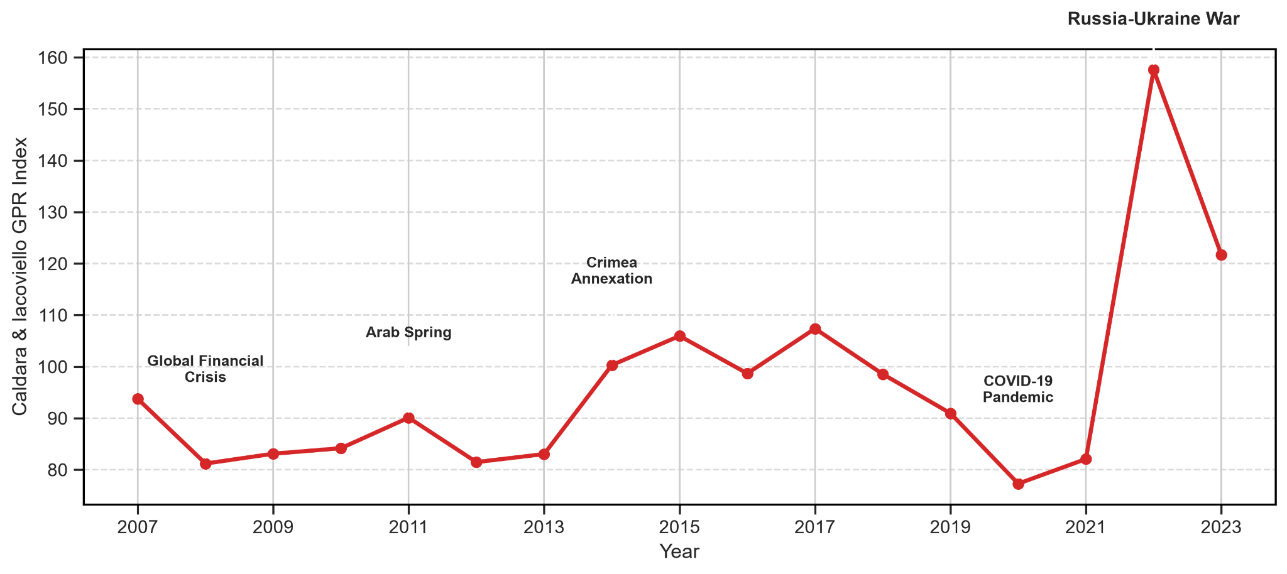
Notes: Annual mean of the global GPR index of Caldara and Iacoviello (2022), in index points (1985–2019 average = 100); selected events annotated
Source: Authors’ compilation based on Caldara and Iacoviello (2022)

4.1. Baseline results of GPR-DTA Nexus on Intermediate-Goods Trade
Table 3 reports the baseline PPML estimates of Equation (1). All specifications include pair–HS2, exporter–year, importer–year and HS2–year fixed effects, absorbing all time-invariant bilateral-product heterogeneity and all multilateral resistance terms (Anderson & van Wincoop, 2003; Head & Mayer, 2014); standard errors are two-way clustered by pair and year.
Column (1) interacts GPR with a binary FTA indicator. The coefficient on GPR × FTA is −0.0241 (p = 0.024): when global geopolitical risk rises by one historical standard deviation, intermediate-goods trade between FTA partners declines by an additional 2.38 percent relative to non-FTA pairs. The estimate is unchanged when 2022 is excluded (−0.0250) but loses precision (p = 0.24), since that year supplies much of the identifying variation.
Column (2) replaces the FTA indicator with DTA depth. The interaction is −0.0053 (p = 0.255), negative but not significant: in isolation, institutional depth does not systematically amplify geopolitical sensitivity.
Column (3) enters both interactions jointly. The FTA interaction strengthens to −0.0382 (p = 0.025, effect −3.75%), while the depth interaction turns positive at +0.0099 (p = 0.202) and is not distinguishable from zero, so no confirmatory inference is drawn from it. The sign reversal must be read with caution: the FTA indicator and the depth measure correlate at 0.73, which constrains the precision with which their interactions are separately identified. The positive coefficient is noted because it conforms to institutional buffering and because the analogous effect is significant when risk is measured at the country-pair level (Table 7, Panel A; Section 4.6).
Table 3. Baseline PPML Gravity estimates: GPR × Trade Agreement interactions
Variable | (1) FTA interaction | (2) Depth interaction | (3) Joint FTA + depth
GPR × DTA depth | – | −0.0053  (0.0047)  [−0.53%] | 0.0099  (0.0078)  [+0.99%]
GPR × FTA | −0.0241**  (0.0107)  [−2.38%] | – | −0.0382**  (0.0171)  [−3.75%]
FTA level term | Included | – | Included
DTA-depth level term | – | Included | Included
Pair–HS2 fixed effects | Yes | Yes | Yes
Exporter–year fixed effects | Yes | Yes | Yes
Importer–year fixed effects | Yes | Yes | Yes
HS2–year fixed effects | Yes | Yes | Yes
Observations | 16,752,356 | 16,752,356 | 16,752,356
Notes: PPML estimates; two-way clustered (pair, year) standard errors in parentheses, marginal effects in brackets. *** p < 0.01, ** p < 0.05, * p < 0.10
Source: Authors’ compilation

4.2. Sectoral heterogeneity through Transmission mechanism of GVC complexity
The aggregate baseline masks heterogeneity across industries differing in value-chain complexity, asset specificity and input substitutability. Equation (5) is estimated separately for the ten pre-specified sector groups; Figure 2 presents the five in which both interactions survive Benjamini–Hochberg (BH-FDR) correction at 10 percent, and Appendix Table A1 reports all ten.
The pattern is consistent with the scope clause of H1. Transport equipment, an archetype of vertically fragmented production with extensive cross-border component sourcing, exhibits the largest FTA interaction (−4.63%, BH-FDR p = 0.026) and depth interaction (−1.83%, p = 0.062). Textiles and footwear show comparable magnitudes (FTA −4.37%, p = 0.003; depth −1.99%, p = 0.005); this is also the sector with the most restrictive rules of origin, so its sensitivity fits the compliance-cost mechanism of Section 2.3 as well as the relationship-specificity one. Machinery and electronics (−3.43%; −1.34%) and precision instruments (−3.15%; −1.72%) follow.
By contrast, sectors trading relatively homogeneous commodities with thick spot markets display positive or near-zero FTA interactions that do not survive correction: agro-food inputs (+2.04%, BH-FDR p = 0.125), minerals and fuels (+0.18%, p = 0.923) and wood products (+3.00%, p = 0.125). The one coefficient signed against the predicted ordering that survives correction is the depth interaction for minerals and fuels (+2.32%, p = 0.062): where inputs can be re-sourced at market prices, deeper agreements do no harm and may help. Both patterns are what re-sourcing through spot markets implies.
This gradient is consistent with the supply-chain interdependence channel and difficult to reconcile with rival explanations that operate uniformly across commodities. It is not a causal identification strategy: sectors with complex value chains also differ in external financial dependence, cyclicality and asset specificity.
Figure 2. Sectoral heterogeneity in the response of Intermediate-goods Trade to Global GPR
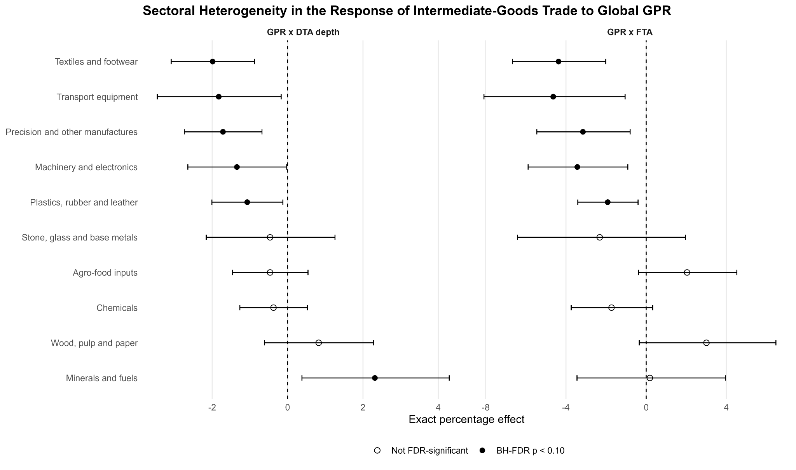
Notes: Point estimates and 95% confidence intervals; filled circles are BH-FDR significant at 10%
Source: Authors’ compilation

4.3. Mechanism analysis of DTA Policy Provisions as Micro-level Shock Absorbers
Because the aggregate depth interaction in Table 3 is not distinguishable from zero, the provision-level analysis below is a search for candidate mechanisms rather than a decomposition of an established effect.

4.3.1. DTA provision bundles
The sixteen coded provisions are grouped into the five bundles of Section 3.2, each estimated separately in FTA-conditional form (Appendix Table A2), since inter-bundle correlations make joint estimates uninformative.
Environmental provisions show a nominally significant interaction (+0.0384, full-bundle effect +3.91%, raw p = 0.049), but the BH-FDR-adjusted value across the five bundles is q = 0.244; because this bundle contains a single provision, the estimate is identical to the provision-level result in Appendix Table A3. Digital and knowledge (+4.63%, q = 0.451), border coordination (+1.80%, q = 0.673), investment and production (+0.72%, q = 0.753) and services and procurement (+0.59%, q = 0.753) show no detectable buffering.

4.3.2. Individual provision screening
Appendix Table A3 screens fourteen of the sixteen provisions individually in FTA-conditional form; information society (287 active pairs) and innovation policy provisions (29 active pairs) are excluded because their support falls below the pre-specified threshold of 500 unordered pairs.
Three provisions are nominally significant at the 5 percent level: competition policy (+3.60%, p = 0.037), environmental laws (+3.91%, p = 0.049) and research and technology cooperation (+3.49%, p = 0.041). None survives Benjamini–Hochberg adjustment (q = 0.228), and three nominal rejections among fourteen tests are roughly what the joint null would produce, so these chapters are exploratory hypotheses for future investigation rather than established mechanisms. We note only that all three are behind-the-border disciplines addressing market contestability and adaptive capability, whereas none of the classical border disciplines (customs, SPS, TBT) or the formal investment chapters shows any mitigating capacity.

4.4. Extensive margin of Trade-Link Survival under Geopolitical Stress

4.4.1. Baseline survival effects
Whether geopolitical risk also destroys relationships entirely is the extensive-margin question. Table 4 presents linear probability estimates of survival for at-risk links (positive trade in t−1), with the same four-dimensional fixed-effect structure. In the joint specification with the lagged size control (Column 5), the GPR × DTA depth interaction is −0.0052 (p = 0.007): ten additional enforceable provisions reduce the one-year survival probability of an established link by 0.52 percentage points per standard deviation of global risk. The GPR × FTA interaction turns positive at +0.0028 (p = 0.086), so that, conditional on depth, membership provides a modest survival premium.
Evaluating the joint marginal effect reveals an institutional threshold. The net response of link survival to a one-standard-deviation GPR shock is ∂Pr(Survival)/∂GPR = 0.28 − 0.52 × (Depth/10) percentage points, which crosses zero at approximately 5.4 enforceable provisions. Below this threshold the preferential tariff advantage dominates and confers a modest survival premium; above it, the compliance penalty outweighs the tariff margin. Because the median active agreement carries 11 provisions (Section 3.2), most operational agreements lie to the right of the turning point.
Table 4. Trade-Link Survival: GPR × Trade Agreement interactions (LPM)
Variable | (1) FTA,  no size | (2) FTA  + size | (3) Depth,  no size | (4) Depth  + size | (5) Joint  + size
GPR × DTA depth | − | − | −0.0040*  (0.0021)  [−0.40 pp] | −0.0042*  (0.0021)  [−0.42 pp] | −0.0052***  (0.0017)  [−0.52 pp]
GPR × FTA | −0.0044  (0.0036)  [−0.44 pp] | −0.0047  (0.0037)  [−0.47 pp] | − | − | 0.0028*  (0.0015)  [+0.28 pp]
Lagged link-size control | No | Yes | No | Yes | Yes
Pair–HS2 fixed effects | Yes | Yes | Yes | Yes | Yes
Exporter–year fixed effects | Yes | Yes | Yes | Yes | Yes
Importer–year fixed effects | Yes | Yes | Yes | Yes | Yes
HS2–year fixed effects | Yes | Yes | Yes | Yes | Yes
Observations | 8,045,131 | 8,045,131 | 8,045,131 | 8,045,131 | 8,045,131
Notes: LPM estimates; two-way clustered (pair, year) standard errors in parentheses, effects in percentage points. *** p < 0.01, ** p < 0.05, * p < 0.10
Source: Authors’ compilation
Figure 3. Marginal effect of Geopolitical Risk on Trade-Link Survival Conditional on DTA Depth
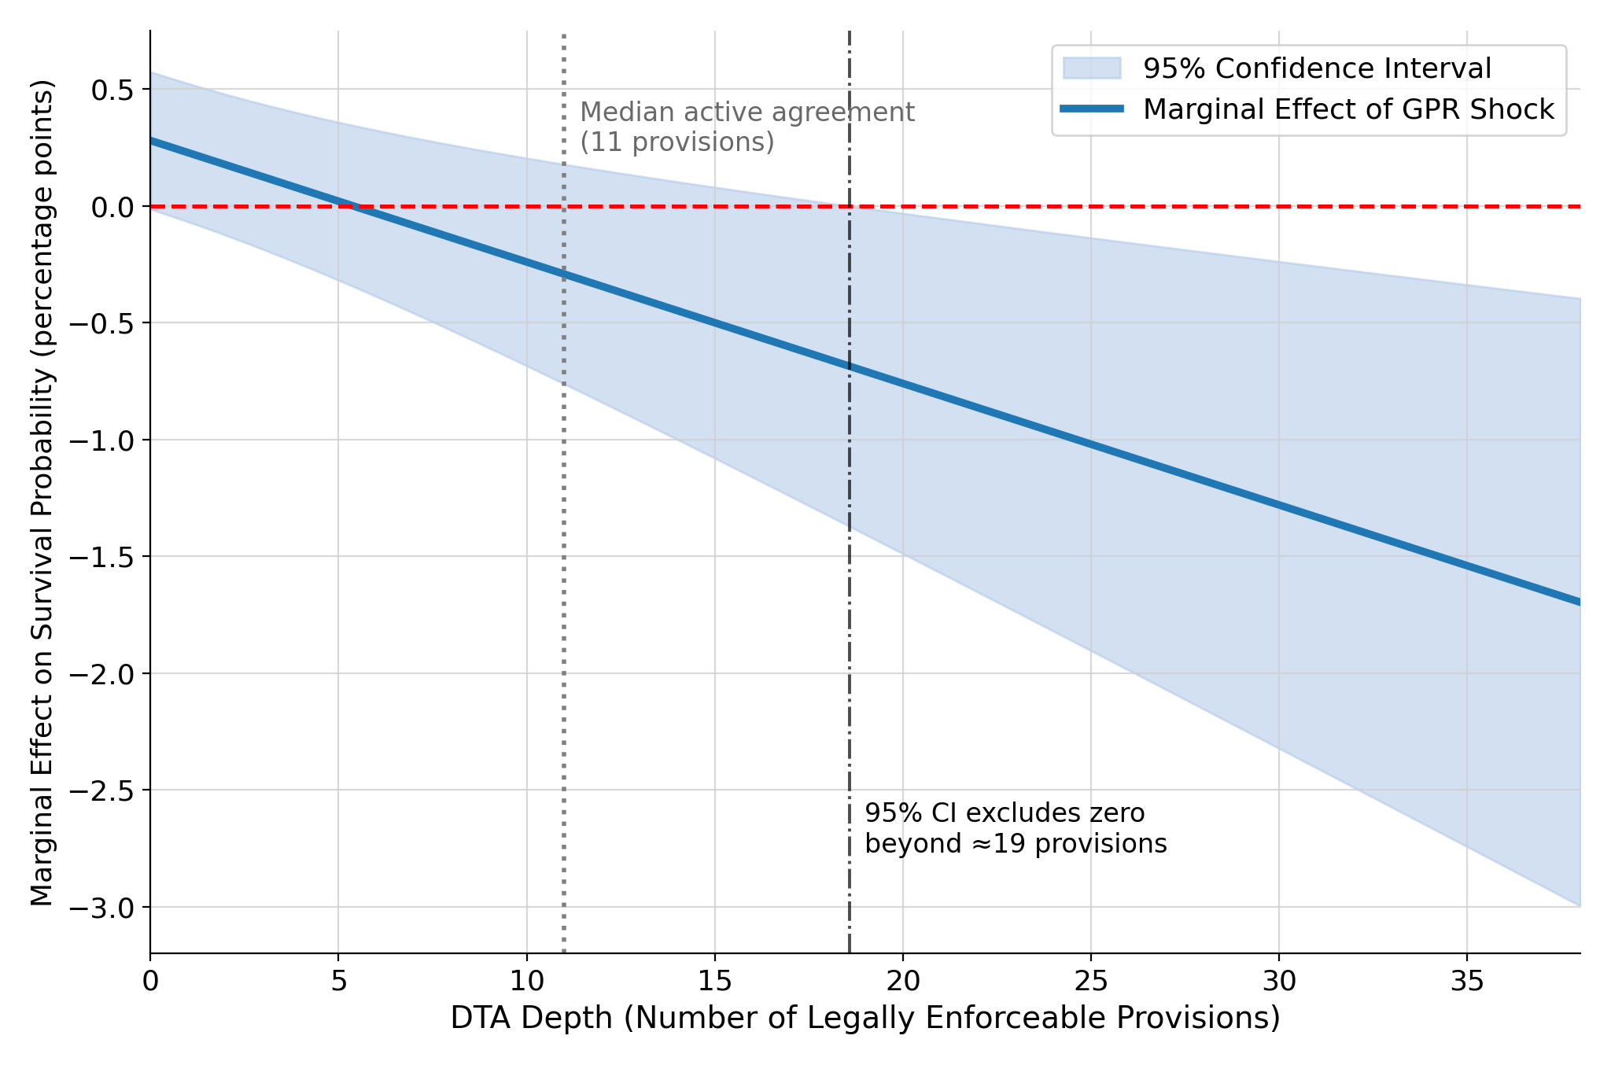
Source: Authors’ compilation
Figure 3 plots the marginal effect of GPR on link survival across the observed range of depth. It is mildly positive for shallow agreements, slopes downward, and its 95 percent interval excludes zero beyond roughly 19 provisions. Deeper agreements impose higher fixed compliance costs - rules-of-origin documentation, conformity assessment and standards certification - that become prohibitive for smaller links when uncertainty raises the option value of waiting, so the weakest links within deep-agreement networks are pruned while core, high-value relationships persist.

4.4.2. Robustness of survival estimates
Table 5 reports robustness checks on the survival result. Panel A shows that the depth penalty is stable across alternative constructions of the global shock: the log annual mean (−0.53 pp, p = 0.008), the threat component (−0.34 pp, p = 0.002) and the annual peak (−0.65 pp, p = 0.007). The acts component gives a point estimate of the same size (−0.37 pp) but is estimated less precisely (p = 0.229); since the two point estimates are nearly identical, the difference in precision is not evidence that firms respond to anticipated rather than realised events.
Panel B of Table 5 shows that the penalty is concentrated among marginal, low-volume relationships: restricting to links with lagged trade above USD 100,000 reduces it by roughly three-quarters to −0.13 pp (p = 0.011), and to −0.14 pp (p = 0.019) above USD 1 million. Administrative burdens, rules-of-origin documentation and conformity certification operate as quasi-fixed annual overheads and bear disproportionately on small flows, which are pruned first.
Panel C of Table 5 re-estimates the depth interaction within pairs that maintained an active agreement in the preceding year, removing the non-preferential comparison group. The point estimate is stable (−0.46 pp against −0.52 pp), although the 57 percent contraction in sample size, from 8.05 million to 3.48 million observations, inflates the clustered standard error and the coefficient is not significant at conventional levels (p = 0.162). Its stability is consistent with, though does not establish, a penalty driven by depth itself rather than by selection into agreement status.
Figure 4 reports a leave-one-year-out analysis. Across all 16 iterations the GPR × depth interaction remains between −0.68 and −0.40 pp and significant at p < 0.01 under pair clustering; under pair-plus-year clustering it is significant at p < 0.10 in all 16 and at p < 0.05 in 15, the exception being the omission of 2022, which removes the largest shock and widens the interval. No single episode drives the finding.
Table 5. Survival robustness: Alternative GPR measures and Sample Restrictions
Panel | Check | Estimate | SE | Effect (pp) | p-value | N
A. Alternative global GPR | Baseline annual mean GPR | −0.0052 | 0.0017 | −0.52 | 0.007 | 8,045,131
 | Log annual mean GPR | −0.0053 | 0.0017 | −0.53 | 0.008 | 8,045,131
 | GPR threats | −0.0034 | 0.0009 | −0.34 | 0.002 | 8,045,131
 | GPR acts | −0.0037 | 0.0030 | −0.37 | 0.229 | 8,045,131
 | Annual peak GPR | −0.0065 | 0.0021 | −0.65 | 0.007 | 8,045,131
B. Established-link samples | Lagged trade ≥ USD 100,000 | −0.0013 | 0.0004 | −0.13 | 0.011 | 3,842,229
 | Lagged trade ≥ USD 1 million | −0.0014 | 0.0006 | −0.14 | 0.019 | 2,079,423
C. Active-FTA-only sample | FTA-only, size-adjusted | −0.0046 | 0.0031 | −0.46 | 0.162 | 3,479,262
Notes: Two-way clustered (pair, year) standard errors. *** p < 0.01, ** p < 0.05, * p < 0.10. Source: Authors’ compilation
Figure 4. Leave-One-Year-Out Estimates of the DTA Depth–Survival interaction
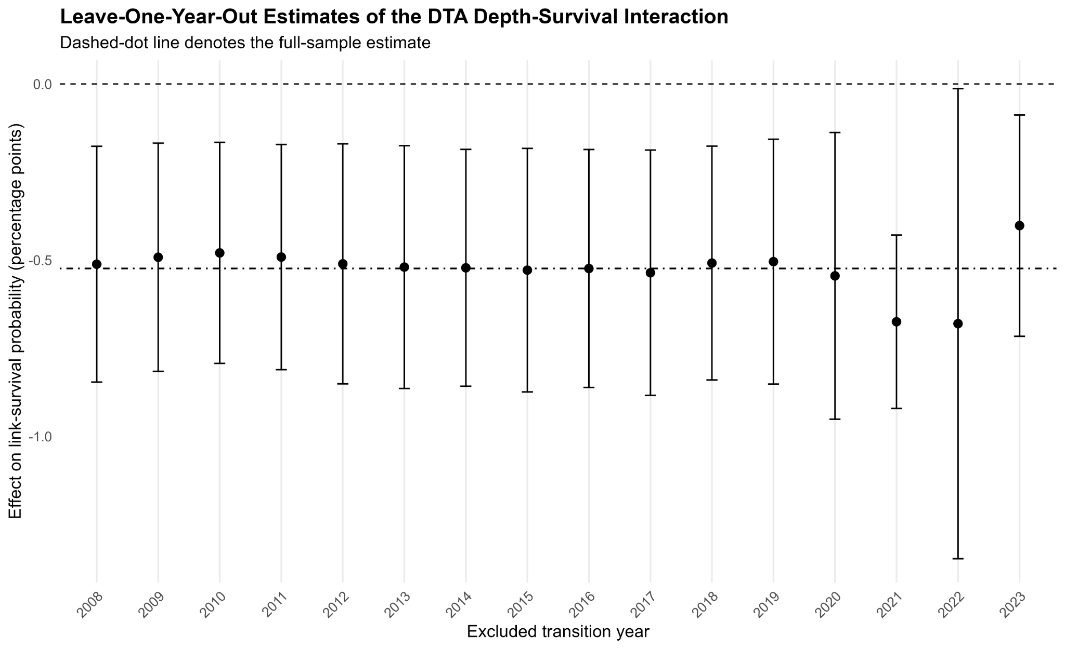
Notes: Leave-one-year-out estimates of the GPR × DTA Depth interaction; bars are 95% confidence intervals. Source: Authors’ compilation

4.5. Post-Exit Recovery Dynamics
Table 6 reports estimates of Equation (4) for four post-exit outcomes - re-entry within one and two years and full value recovery within one and two years - on 1,151,310 exit events observed between 2008 and 2022, with directed-pair fixed effects as the baseline and pair–HS2 effects as the stringent specification.
Under directed-pair effects, the GPR × Depth interaction for one-year re-entry is −0.0035 (p = 0.044, −0.35 pp), which would indicate that deeper agreements slow the reconstitution of severed links. The result is fragile: under pair–HS2 effects it falls to −0.01 pp (p = 0.951), the two-year coefficient (+0.0001, SE 0.0035) has an interval wide enough to contain the one-year estimate, and the full-recovery outcomes are imprecise at both horizons (p > 0.40). The test of H3(b) therefore lacks the power to separate transitory friction from permanent hysteresis: there is no robust indication that depth impedes re-entry, and the paper’s conclusions rest on the survival results.
Appendix Table A4 reports net GPR interaction effects at representative depth levels; for one-year re-entry the net effect is negative only at high depth (20 provisions: −0.57 pp, p = 0.003; 30 provisions: −0.93 pp, p = 0.007), subject to the same fragility.
Table 6. Post-Exit Recovery: GPR × DTA Depth interactions (LPM)
Outcome | Directed-pair FE | N | Pair–HS2 FE | N
Re-entry within one year | −0.0035**  (0.0016)  [−0.35 pp] | 1,151,310 | −0.0001  (0.0021)  [−0.01 pp] | 839,585
Re-entry within two years | 0.0001  (0.0035)  [+0.01 pp] | 1,064,542 | 0.0013  (0.0056)  [+0.13 pp] | 752,846
Full recovery within one year | −0.0009  (0.0011)  [−0.09 pp] | 1,151,310 | 0.0005  (0.0016)  [+0.05 pp] | 839,585
Full recovery within two years | −0.0002  (0.0036)  [−0.02 pp] | 1,064,542 | 0.0041  (0.0059)  [+0.41 pp] | 752,846
Notes: LPM estimates; standard errors clustered on pair and exit year, effects in percentage points. *** p < 0.01, ** p < 0.05, * p < 0.10. Source: Authors’ compilation

4.6. Country-specific Geopolitical Risk
Panel A of Table 7 shows that depth buffers trade values once geopolitical risk is measured at the bilateral country-pair level. With the average pair-country GPR, the FTA interaction is −0.0852 (p = 0.007, −8.17%) and the GPR × DTA depth interaction turns positive and significant at +0.0280 (p = 0.018, +2.84%); the log-average and maximum pair measures give +2.81% and +2.43%.
Because the 44 economies with national series are systematically larger and more integrated (946 pairs), the restricted-sample global GPR benchmark in the fourth row separates sample composition from the shock measure. Restricting the sample while retaining global GPR moves the depth coefficient from +0.0099 to +0.0160 (p = 0.143), about a third of the total shift; replacing the global with the pair measure accounts for the remaining two-thirds and for the gain in precision. Part of the larger coefficient is scale (Section 3.2), but the change in precision is not. Buffering therefore appears where treaty disciplines align with the bilateral exposure they can govern, not under a common global shock.
Panel B applies the same measures to link survival, alongside the restricted-sample global benchmark. Under pair-specific risk, depth protects the value of continuing flows (+2.84% per ten provisions) but continues to reduce link survival (−0.17 pp per ten provisions, p < 0.001), as it does under global risk within the same subsample (−0.38 pp). Depth protects relationship value while pruning relationship count, so an evaluation that tracks only aggregate trade values would record insurance while the underlying network thins.
Table 7. Country-specific GPR Robustness
Shock measure | GPR × FTA | GPR × DTA depth | N
Panel A. Intermediate-goods trade value (PPML)
Average pair-country GPR | −0.0852***  (0.0319)  [−8.17%] | 0.0280**  (0.0118)  [+2.84%] | 2,520,781
Log-average pair-country GPR | −0.0843***  (0.0294)  [−8.09%] | 0.0277**  (0.0111)  [+2.81%] | 2,520,781
Maximum pair-country GPR | −0.0796**  (0.0339)  [−7.65%] | 0.0240*  (0.0129)  [+2.43%] | 2,520,781
Restricted-sample global GPR | −0.0617***  (0.0217)  [−5.98%] | 0.0160  (0.0109)  [+1.62%] | 2,520,781
Panel B. Trade-link survival (LPM)
Average pair-country GPR | −0.0006  (0.0020)  [−0.06 pp] | −0.0017***  (0.0004)  [−0.17 pp] | 1,878,443
Log-average pair-country GPR | −0.0014  (0.0019)  [−0.14 pp] | −0.0015***  (0.0004)  [−0.15 pp] | 1,878,443
Maximum pair-country GPR | 0.0007  (0.0021)  [+0.07 pp] | −0.0020***  (0.0005)  [−0.20 pp] | 1,878,443
Restricted-sample global GPR | 0.0029*  (0.0016)  [+0.29 pp] | −0.0038***  (0.0010)  [−0.38 pp] | 1,878,443
Notes: Two-way clustered (pair, year) standard errors in parentheses. *** p < 0.01, ** p < 0.05, * p < 0.10. Source: Authors’ compilation

5. Conclusion

5.1. Policy implications
Three findings stand out. Trade between agreement partners falls by a further 2.38 percent per standard deviation of global geopolitical risk, concentrated in differentiated manufacturing (H1); depth has no distinguishable average effect on trade values under a global shock but a protective one under pair-specific risk (H2); and each ten enforceable provisions lower one-year link survival by 0.52 percentage points, the most stable estimate in the paper (H3a), with no robust effect on re-entry (H3b). Four implications follow.
First, the evaluation of trade agreements must measure both margins. Ex-post assessments track trade value, on which a deep agreement under geopolitical stress looks like insurance; beneath it the network thins one small link at a time. Monitoring frameworks, and any test of the premise that friend-shoring makes partner supply chains more resilient (Javorcik et al., 2024), should report the number and survival of active pair–product links alongside value, and ask whether a lost link is replaced from a third country or lost outright.
Second, the compliance cost of preferential status is the operative policy lever, and it should be scaled to relationship size. The links that disappear are the small and young ones, for which a fixed annual cost of origin certification, conformity assessment and documentation is largest per unit of trade (Anson et al., 2005; Hakobyan, 2015). Self-certification of origin, de minimis thresholds, simplified procedures for low-value consignments and broader cumulation reduce that cost without altering the preference margin.
Third, diversification is not a by-product of deep integration. Openness lowers volatility when shocks are country-specific and can be pooled across partners (Caselli et al., 2020); global geopolitical risk is a common shock, and a bloc of deep agreements concentrates sourcing among partners exposed to it together, so friend-shoring built on institutional depth may raise the co-movement of supply-chain trade rather than reduce risk. Resilience should be assessed as an objective separate from integration (Grossman et al., 2023).
Fourth, the results do not identify which provisions do the work: the three nominally significant disciplines fail correction for multiple testing and are hypotheses for a focused design, not a template for negotiation.
Institutional depth is therefore not a substitute for resilience policy: deep integration buys efficiency, not resilience, and on the evidence here the two can trade off against each other.

5.2. Limitations and prospects
Several limitations point to extensions.
One concerns the assignment of depth. Pairs with dense production-network trade sign deeper agreements (Orefice & Rocha, 2014), and pair–chapter fixed effects with lagged treatment absorb only the time-invariant part of that selection (Baier & Bergstrand, 2007); measuring depth at the date of signature, or an event study around entry into force, would test whether the effect predates the agreement’s own reshaping of the relationship.
Another concerns the shock: global geopolitical risk has no cross-sectional variation, so identification rests entirely on interactions with exposure, and the country-specific extension relaxes this only on 44 systematically larger economies. A design separating anticipated from realised conflict would sharpen the shock itself.
The unit of observation is a pair–chapter link, not a firm: an exit may be one exporter leaving a market or every exporter leaving it. Transaction-level customs data would separate the firm margin from the product margin and allow compliance-cost heterogeneity by firm size, on which selective pruning turns, to be tested directly.
Inference carries two caveats: the fitted values of the linear probability model are not bounded to the unit interval, and a discrete-time hazard with the same fixed-effect structure is the natural check (Hess & Persson, 2012); and the incidental-parameter corrections available for Poisson gravity are derived for three-way models (Weidner & Zylkin, 2021). The survival result does not depend on marginal significance; the trade-value estimates are less comfortably placed.
The data record the death of a link but not its replacement: an importer that loses a supplier in one partner may re-source the same chapter from a third country, so pair-level destruction may be importer-level diversion. Following importer–chapter imports across all origins after an exit would show whether pruning reduces total sourcing or merely relocates it.
Finally, the mechanism is inferred from a conjunction of signs across two margins, not observed. A direct test requires data on preference utilisation, so that links which stop claiming preferences can be distinguished from links which stop trading; that distinction is where the next study of deep agreements under geopolitical risk should begin.

REFERENCES
Anderson, J. E., & van Wincoop, E. (2003). Gravity with gravitas: A solution to the border puzzle. American Economic Review, 93(1), 170–192. doi:10.1257/000282803321455214
Anson, J., Cadot, O., Estevadeordal, A., de Melo, J., Suwa-Eisenmann, A., & Tumurchudur, B. (2005). Rules of origin in North–South preferential trading arrangements with an application to NAFTA. Review of International Economics, 13(3), 501–517. doi:10.1111/j.1467-9396.2005.00520.x
Antràs, P. (2003). Firms, contracts, and trade structure. The Quarterly Journal of Economics, 118(4), 1375–1418. doi:10.1162/003355303322552829
Antràs, P., & Helpman, E. (2004). Global sourcing. Journal of Political Economy, 112(3), 552–580. doi:10.1086/383099
Baier, S. L., & Bergstrand, J. H. (2007). Do free trade agreements actually increase members' international trade? Journal of International Economics, 71(1), 72–95. doi:10.1016/j.jinteco.2006.02.005
Baker, S. R., Bloom, N., & Davis, S. J. (2016). Measuring economic policy uncertainty. The Quarterly Journal of Economics, 131(4), 1593–1636. doi:10.1093/qje/qjw024
Baldwin, R., & Krugman, P. (1989). Persistent trade effects of large exchange rate shocks. The Quarterly Journal of Economics, 104(4), 635–654. doi:10.2307/2937860
Barrot, J.-N., & Sauvagnat, J. (2016). Input specificity and the propagation of idiosyncratic shocks in production networks. The Quarterly Journal of Economics, 131(3), 1543–1592. doi:10.1093/qje/qjw018
Benguria, F. (2022). Do US exporters take advantage of free trade agreements? Evidence from the US–Colombia free trade agreement. Review of International Economics, 30(4), 1148–1179. doi:10.1111/roie.12598
Benjamini, Y., & Hochberg, Y. (1995). Controlling the false discovery rate: A practical and powerful approach to multiple testing. Journal of the Royal Statistical Society: Series B (Methodological), 57(1), 289–300. doi:10.1111/j.2517-6161.1995.tb02031.x
Besedeš, T., & Prusa, T. J. (2006a). Ins, outs, and the duration of trade. Canadian Journal of Economics, 39(1), 266–295. doi:10.1111/j.0008-4085.2006.00347.x
Besedeš, T., & Prusa, T. J. (2006b). Product differentiation and duration of US import trade. Journal of International Economics, 70(2), 339–358. doi:10.1016/j.jinteco.2005.12.005
Besedeš, T., & Prusa, T. J. (2013). Antidumping and the death of trade (NBER Working Paper No. 19555). Cambridge, MA: National Bureau of Economic Research. doi:10.3386/w19555
Bloom, N. (2009). The impact of uncertainty shocks. Econometrica, 77(3), 623–685. doi:10.3982/ecta6248
Boehm, C. E., Flaaen, A., & Pandalai-Nayar, N. (2019). Input linkages and the transmission of shocks: Firm-level evidence from the 2011 Tōhoku earthquake. The Review of Economics and Statistics, 101(1), 60–75. doi:10.1162/rest_a_00750
Bombarda, P., & Gamberoni, E. (2013). Firm heterogeneity, rules of origin, and rules of cumulation. International Economic Review, 54(1), 307–328. doi:10.1111/j.1468-2354.2012.00734.x
Brenton, P., Saborowski, C., & von Uexkull, E. (2010). What explains the low survival rate of developing country export flows? The World Bank Economic Review, 24(3), 474–499. doi:10.1093/wber/lhq015
Caldara, D., & Iacoviello, M. (2022). Measuring geopolitical risk. American Economic Review, 112(4), 1194–1225. doi:10.1257/aer.20191823
Cameron, A. C., Gelbach, J. B., & Miller, D. L. (2011). Robust inference with multiway clustering. Journal of Business & Economic Statistics, 29(2), 238–249. doi:10.1198/jbes.2010.07136
Campos, R. G., Estefania-Flores, J., Furceri, D., & Timini, J. (2023). Geopolitical fragmentation and trade. Journal of Comparative Economics, 51(4), 1289–1315. doi:10.1016/j.jce.2023.06.008
Caselli, F., Koren, M., Lisicky, M., & Tenreyro, S. (2020). Diversification through trade. The Quarterly Journal of Economics, 135(1), 449–502. doi:10.1093/qje/qjz028
Conconi, P., García-Santana, M., Puccio, L., & Venturini, R. (2018). From final goods to inputs: The protectionist effect of rules of origin. American Economic Review, 108(8), 2335–2365. doi:10.1257/aer.20161151
Correia, S., Guimarães, P., & Zylkin, T. (2020). Fast Poisson estimation with high-dimensional fixed effects. The Stata Journal, 20(1), 95–115. doi:10.1177/1536867x20909691
Crozet, M., & Hinz, J. (2020). Friendly fire: The trade impact of the Russia sanctions and counter-sanctions. Economic Policy, 35(101), 97–146. doi:10.1093/epolic/eiaa006
Das, S., Roberts, M. J., & Tybout, J. R. (2007). Market entry costs, producer heterogeneity, and export dynamics. Econometrica, 75(3), 837–873. doi:10.1111/j.1468-0262.2007.00769.x
Dixit, A. (1989). Entry and exit decisions under uncertainty. Journal of Political Economy, 97(3), 620–638. doi:10.1086/261619
Dür, A., Baccini, L., & Elsig, M. (2014). The design of international trade agreements: Introducing a new dataset. The Review of International Organizations, 9(3), 353–375. doi:10.1007/s11558-013-9179-8
Elliott, M., Golub, B., & Leduc, M. V. (2022). Supply network formation and fragility. American Economic Review, 112(8), 2701–2747. doi:10.1257/aer.20210220
Gaulier, G., & Zignago, S. (2010). BACI: International trade database at the product-level (the 1994–2007 version) (CEPII Working Paper No. 2010-23). Paris, France: CEPII. doi:10.2139/ssrn.1994500
Gopinath, G., Gourinchas, P.-O., Presbitero, A. F., & Topalova, P. (2025). Changing global linkages: A new Cold War? Journal of International Economics, 153, 104042. doi:10.1016/j.jinteco.2024.104042
Grossman, G. M., Helpman, E., & Lhuillier, H. (2023). Supply chain resilience: Should policy promote international diversification or reshoring? Journal of Political Economy, 131(12), 3462–3496. doi:10.1086/725173
Hakobyan, S. (2015). Accounting for underutilization of trade preference programs: The US generalized system of preferences. Canadian Journal of Economics, 48(2), 408–436. doi:10.1111/caje.12131
Handley, K., & Limão, N. (2017). Policy uncertainty, trade, and welfare: Theory and evidence for China and the United States. American Economic Review, 107(9), 2731–2783. doi:10.1257/aer.20141419
Hayakawa, K. (2023). Multiple preference regimes and rules of origin. Review of World Economics, 159(3), 673–696. doi:10.1007/s10290-022-00479-w
Head, K., & Mayer, T. (2014). Gravity equations: Workhorse, toolkit, and cookbook. In G. Gopinath, E. Helpman, & K. Rogoff (Eds.), Handbook of international economics (Vol. 4, pp. 131–195). Amsterdam, The Netherlands: Elsevier. doi:10.1016/b978-0-444-54314-1.00003-3
Head, K., Mayer, T., & Melitz, M. (2024). The Laffer curve for rules of origin. Journal of International Economics, 150, 103911. doi:10.1016/j.jinteco.2024.103911
Hess, W., & Persson, M. (2012). The duration of trade revisited: Continuous-time versus discrete-time hazards. Empirical Economics, 43(3), 1083–1107. doi:10.1007/s00181-011-0518-4
Hofmann, C., Osnago, A., & Ruta, M. (2019). The content of preferential trade agreements. World Trade Review, 18(3), 365–398. doi:10.1017/S1474745618000071
Horn, H., Maggi, G., & Staiger, R. W. (2010). Trade agreements as endogenously incomplete contracts. American Economic Review, 100(1), 394–419. doi:10.1257/aer.100.1.394
Javorcik, B. S., Kitzmüller, L., Schweiger, H., & Yıldırım, M. A. (2024). Economic costs of friendshoring. The World Economy, 47(7), 2871–2908. doi:10.1111/twec.13555
Kramarz, F., Martin, J., & Méjean, I. (2020). Volatility in the small and in the large: The lack of diversification in international trade. Journal of International Economics, 122, 103276. doi:10.1016/j.jinteco.2019.103276
Laget, E., Osnago, A., Rocha, N., & Ruta, M. (2020). Deep trade agreements and global value chains. Review of Industrial Organization, 57(2), 379–410. doi:10.1007/s11151-020-09780-0
Mattoo, A., Mulabdic, A., & Ruta, M. (2022). Trade creation and trade diversion in deep agreements. Canadian Journal of Economics, 55(3), 1598–1637. doi:10.1111/caje.12611
Mattoo, A., Rocha, N., & Ruta, M. (Eds.). (2020). Handbook of deep trade agreements. Washington, DC: World Bank. doi:10.1596/978-1-4648-1539-3
Melitz, M. J. (2003). The impact of trade on intra-industry reallocations and aggregate industry productivity. Econometrica, 71(6), 1695–1725. doi:10.1111/1468-0262.00467
Nitsch, V. (2009). Die another day: Duration in German import trade. Review of World Economics, 145(1), 133–154. doi:10.1007/s10290-009-0008-3
Novy, D., & Taylor, A. M. (2020). Trade and uncertainty. The Review of Economics and Statistics, 102(4), 749–765. doi:10.1162/rest_a_00885
Nunn, N. (2007). Relationship-specificity, incomplete contracts, and the pattern of trade. The Quarterly Journal of Economics, 122(2), 569–600. doi:10.1162/qjec.122.2.569
Obashi, A. (2010). Stability of production networks in East Asia: Duration and survival of trade. Japan and the World Economy, 22(1), 21–30. doi:10.1016/j.japwor.2009.06.002
Orefice, G., & Rocha, N. (2014). Deep integration and production networks: An empirical analysis. The World Economy, 37(1), 106–136. doi:10.1111/twec.12076
Osnago, A., Rocha, N., & Ruta, M. (2019). Deep trade agreements and vertical FDI: The devil is in the details. Canadian Journal of Economics, 52(4), 1558–1599. doi:10.1111/caje.12413
Rauch, J. E. (1999). Networks versus markets in international trade. Journal of International Economics, 48(1), 7–35. doi:10.1016/s0022-1996(98)00009-9
Santos Silva, J. M. C., & Tenreyro, S. (2006). The log of gravity. The Review of Economics and Statistics, 88(4), 641–658. doi:10.1162/rest.88.4.641
Weidner, M., & Zylkin, T. (2021). Bias and consistency in three-way gravity models. Journal of International Economics, 132, 103513. doi:10.1016/j.jinteco.2021.103513
Yotov, Y. V., Piermartini, R., Monteiro, J.-A., & Larch, M. (2016). An advanced guide to trade policy analysis: The structural gravity model. Geneva, Switzerland: World Trade Organization and United Nations Conference on Trade and Development. doi:10.30875/abc0167e-en

APPENDIX
Appendix Table A1. Sector Heterogeneity: GPR × Trade Agreement interactions by HS2 Manufacturing group
Sector | GPR × FTA | BH-FDR p | GPR × DTA depth | BH-FDR p | N
Textiles and footwear | −0.0447***  (0.0124)  [−4.37%] | 0.003 | −0.0201***  (0.0058)  [−1.99%] | 0.005 | 2,522,056
Transport equipment | −0.0474**  (0.0188)  [−4.63%] | 0.026 | −0.0184*  (0.0085)  [−1.83%] | 0.062 | 669,321
Precision and other manufactures | −0.0320**  (0.0123)  [−3.15%] | 0.026 | −0.0173***  (0.0053)  [−1.72%] | 0.006 | 1,171,921
Machinery and electronics | −0.0349**  (0.0131)  [−3.43%] | 0.026 | −0.0135*  (0.0068)  [−1.34%] | 0.077 | 723,655
Plastics, rubber and leather | −0.0194**  (0.0078)  [−1.92%] | 0.026 | −0.0108*  (0.0049)  [−1.07%] | 0.062 | 947,987
Chemicals | −0.0174 (0.0105) [−1.73%] | 0.125 | −0.0037 (0.0046) [−0.37%] | 0.460 | 2,416,561
Stone, glass and base metals | −0.0235 (0.0219) [−2.32%] | 0.315 | −0.0047 (0.0088) [−0.47%] | 0.594 | 3,280,112
Agro-food inputs | 0.0202 (0.0123) [+2.04%] | 0.125 | −0.0047 (0.0051) [−0.47%] | 0.454 | 3,280,602
Minerals and fuels | 0.0018 (0.0188) [+0.18%] | 0.923 | 0.0229* (0.0097) [+2.32%] | 0.062 | 609,012
Wood, pulp and paper | 0.0296 (0.0169) [+3.00%] | 0.125 | 0.0082 (0.0073) [+0.82%] | 0.376 | 1,131,024
Notes: Two-way clustered (pair, year) standard errors; asterisks denote BH-FDR q-values: *** q < 0.01, ** q < 0.05, * q < 0.10. Source: Authors’ compilation
Appendix Table A2. DTA Mechanism Bundles: GPR × Bundle Depth interactions (FTA-Conditional)
Bundle | Estimate | SE | Full-bundle  effect (%) | Raw p | BH-FDR p | N
Environmental provisions | 0.0384 | 0.0195 | +3.91% | 0.049 | 0.244 | 16,752,356
Digital and knowledge | 0.0453 | 0.0338 | +4.63% | 0.180 | 0.451 | 16,752,356
Border coordination | 0.0178 | 0.0213 | +1.80% | 0.404 | 0.673 | 16,752,356
Investment and production | 0.0072 | 0.0180 | +0.72% | 0.691 | 0.753 | 16,752,356
Services and procurement | 0.0059 | 0.0188 | +0.59% | 0.753 | 0.753 | 16,752,356
Notes: Two-way clustered (pair, year) standard errors; BH-FDR q-values. The environmental bundle contains only environmental laws. Source: Authors’ compilation

Appendix Table A3. Individual DTA Provision Screening: GPR × Provision interactions (FTA-Conditional)
Provision | Estimate | SE | Effect (%) | Raw p | BH-FDR p | N
Competition policy | 0.0353 | 0.0169 | +3.60% | 0.037 | 0.228 | 16,752,356
Environmental laws | 0.0384 | 0.0195 | +3.91% | 0.049 | 0.228 | 16,752,356
Research and technology | 0.0343 | 0.0168 | +3.49% | 0.041 | 0.228 | 16,752,356
Public procurement | 0.0330 | 0.0208 | +3.36% | 0.112 | 0.313 | 16,752,356
Movement of capital | 0.0215 | 0.0123 | +2.17% | 0.081 | 0.283 | 16,752,356
Technical barriers to trade | 0.0205 | 0.0173 | +2.08% | 0.235 | 0.412 | 16,752,356
Intellectual property rights | 0.0160 | 0.0188 | +1.61% | 0.395 | 0.503 | 16,752,356
Trade-related intellectual property | 0.0160 | 0.0141 | +1.61% | 0.255 | 0.412 | 16,752,356
SPS measures | 0.0150 | 0.0162 | +1.51% | 0.355 | 0.497 | 16,752,356
Data protection | 0.0146 | 0.0131 | +1.47% | 0.265 | 0.412 | 16,752,356
Trade-related investment measures | 0.0004 | 0.0100 | +0.04% | 0.969 | 0.969 | 16,752,356
Customs | −0.0024 | 0.0154 | −0.24% | 0.877 | 0.945 | 16,752,356
Investment | −0.0119 | 0.0152 | −1.18% | 0.437 | 0.509 | 16,752,356
Trade in services | −0.0207 | 0.0168 | −2.05% | 0.216 | 0.412 | 16,752,356
Notes: Two-way clustered (pair, year) standard errors; BH-FDR q-values. Excludes information society and innovation policies (< 500 pairs). Source: Authors’ compilation

Appendix Table A4. Post-Exit Recovery: Net GPR Interaction effects at Representative Depth Levels
Outcome | Enforceable  provisions | Net effect (pp) | p-value | N
Re-entry within one year | 0 | +0.14 pp | 0.570 | 1,151,310
 | 10 | −0.22 pp | 0.089 | 1,151,310
 | 20 | −0.57 pp | 0.003 | 1,151,310
 | 30 | −0.93 pp | 0.007 | 1,151,310
Re-entry within two years | 0 | +0.35 pp | 0.567 | 1,064,542
 | 10 | +0.36 pp | 0.451 | 1,064,542
 | 20 | +0.37 pp | 0.527 | 1,064,542
 | 30 | +0.38 pp | 0.653 | 1,064,542
Full recovery within one year | 0 | −0.02 pp | 0.912 | 1,151,310
 | 10 | −0.11 pp | 0.291 | 1,151,310
 | 20 | −0.19 pp | 0.116 | 1,151,310
 | 30 | −0.28 pp | 0.187 | 1,151,310
Full recovery within two years | 0 | −0.07 pp | 0.901 | 1,064,542
 | 10 | −0.10 pp | 0.826 | 1,064,542
 | 20 | −0.12 pp | 0.827 | 1,064,542
 | 30 | −0.14 pp | 0.863 | 1,064,542
Notes: Two-way clustered (pair, year) standard errors. *** p < 0.01, ** p < 0.05, * p < 0.10. Source: Authors’ compilation

Appendix Figure A1. Country-specific GPR Robustness: Trade Value and Link Survival
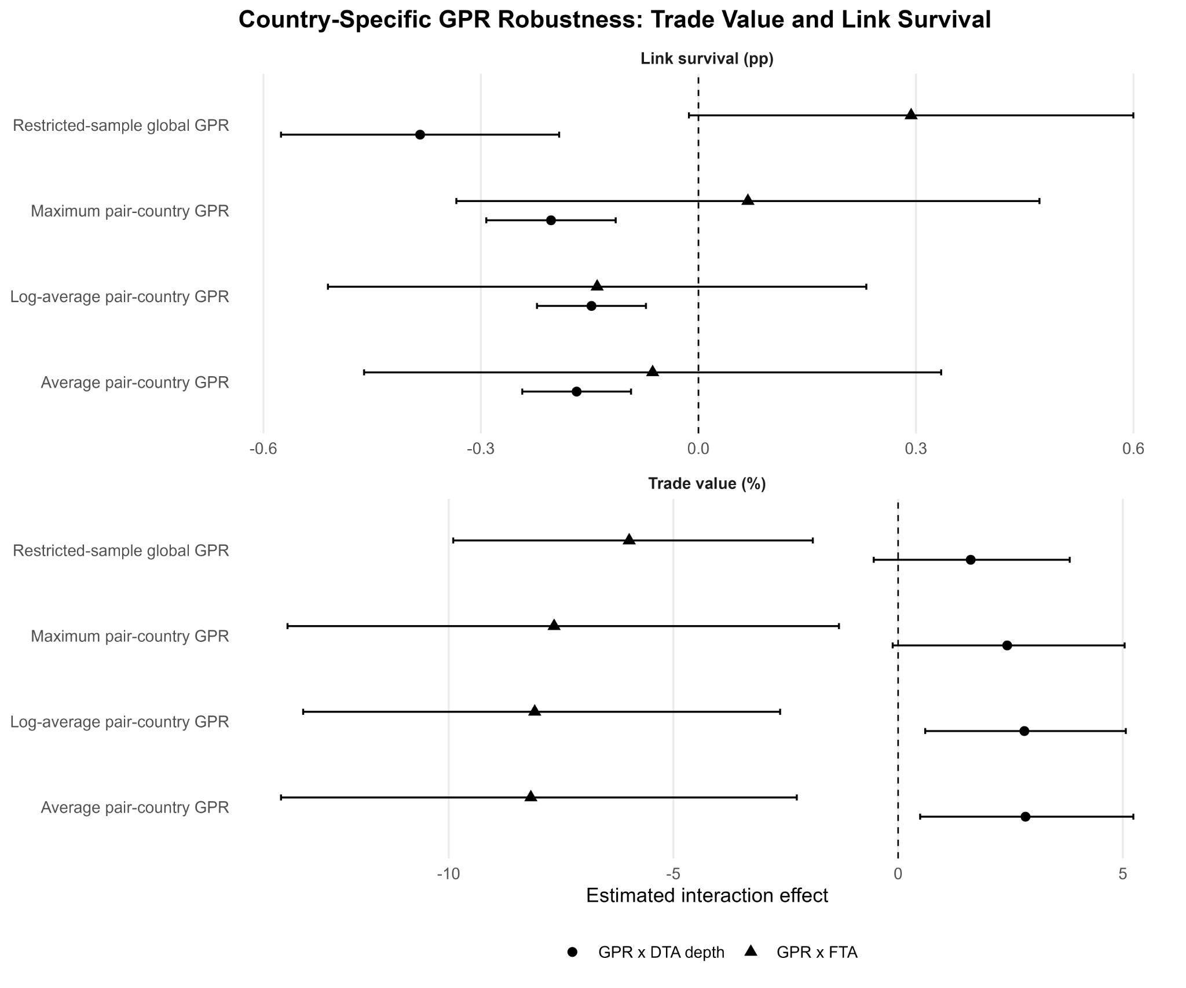
Notes: Point estimates and 95% confidence intervals for the country-specific GPR specifications. Source: Authors’ compilation

Corresponding author

